**Project: Digital Marketing and SEO Optimization at JiViSa**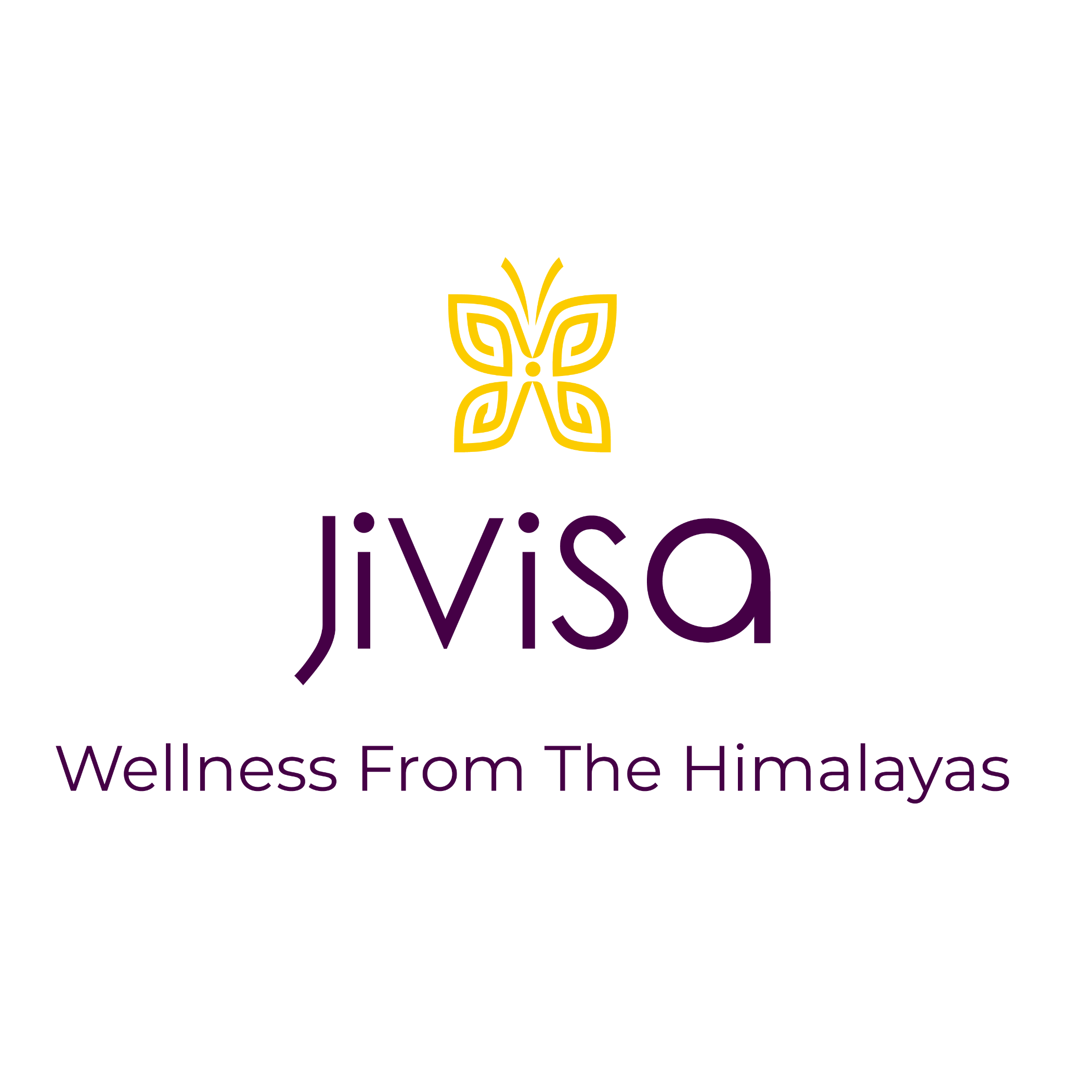

**Duration: January 2024 - May 2024**

**Role: Digital Marketing and SEO Specialist**

**Company Overview:**

JiViSa is a wellness brand dedicated to providing natural health and wellness products sourced from the Himalayas. With a focus on purity and authenticity, JiViSa offers a range of products designed to promote holistic health.

**Project Overview:**

During my tenure at JiViSa, I played a pivotal role in enhancing the company's digital presence through comprehensive digital marketing and SEO strategies. My responsibilities included managing the Shopify website, optimizing product listings, conducting SEO at various levels, and participating in basic marketing calls. Additionally, I onboarded a client and provided extensive digital marketing support.

**Key Responsibilities:**

**Shopify Management:**

Managed the JiViSa Shopify website, ensuring seamless user experience and product accessibility.

Handled product listings, including descriptions, images, and categorization to enhance visibility and user engagement.

**SEO Optimization:**

Initial Analysis: At the start of my tenure in January 2024, the overall site score was 61/100.

On-Page SEO: Implemented on-page SEO strategies, including optimizing alt tags, meta descriptions, and keywords.

Performance Optimization: Enhanced site speed, fixed broken links, and ensured mobile responsiveness.

Outcome: By the end of my tenure in May 2024, achieved A+ ratings in both On-Page SEO and Performance, reflecting significant improvements.

**Digital Marketing:**

Participated in marketing calls to discuss and strategize promotional campaigns.

Provided digital marketing support, including social media management and content creation.

**Client Onboarding and Support:**

Onboarded a new client, guiding them through the initial setup and digital marketing strategies.

Offering continuous support to ensure their digital marketing efforts were effective and aligned with their goals.

**Achievements:**

Successfully elevated JiViSa's SEO performance from a site score of 61/100 in January 2024 to A+ ratings in On-Page SEO and Performance by May 2024.

Enhanced the overall user experience and search engine rankings through targeted SEO strategies and continuous optimization.

Demonstrated the impact of SEO improvements through measurable metrics, reflecting significant progress in digital presence and customer engagement.

**SEO Strategies Implemented:**

**Keyword Research**: Identified high-volume keywords relevant to JiViSa’s products and incorporated them into product listings and content.

**Content Optimization**: Enhanced product descriptions and blog posts with targeted keywords and SEO best practices.

**Technical SEO:** Improved site speed, mobile responsiveness, and fixed broken links to ensure a better user experience and higher search engine rankings.

**Link Building**: Developed a strategy to acquire high-quality backlinks from reputable sources to boost domain authority.

**Potential SEO Strategies for Further Improvement:**

**Voice Search Optimization:** Tailoring content to match voice search queries, which are becoming increasingly popular.

**Local SEO:** Optimizing for local search terms and creating Google My Business profiles to attract local customers.

**User-Generated Content:** Encouraging customer reviews and testimonials to increase trust and engagement.

**Advanced Analytics:** Utilizing tools like Google Analytics and SEMrush to gain deeper insights into user behavior and further refine SEO strategies.

**Analytical Insights:**

The initial SEO analysis in January 2024 revealed an overall site score of 61/100, highlighting key areas for improvement.

Through targeted strategies and optimizations, the SEO performance significantly improved, achieving A+ ratings in On-Page SEO and Performance by May 2024.

These improvements not only increased the site's search engine rankings but also significantly enhanced the user experience and overall digital presence.

**Conclusion:**

My experience at JiViSa was incredibly rewarding, as I was able to contribute significantly to their digital marketing and SEO efforts. Through a combination of strategic planning, execution, and continuous optimization, I helped enhance JiViSa's online presence, ensuring they are well-positioned for continued growth and success.

Attached: SEO Analysis Report (Before and After)



